Mapleton-Fall Creek Neighborhood Association
Minutes for 04/13/ 2017

6:34 p.m. – Meeting called to order by Ryan Funk, president

Thank you to TAB for the last minute location
Introductions

A reminder, IUPUI’s Anthropology department has a scanner and a student ready to scan any items you may have brought. Please take them to them to be scanned during or after the meeting. If you have forgotten them, they can set a time that is more convenient for you.

6:40 p.m. - Treasurer Report
Thank you for your support of the organization. Dues are $25 for those under 55 and for those over 55, it is $10 per year. Contributory members are $50.

Chase: $6,204.92
Prudential: $6,179.65

6:41 p.m. - Review the March minutes
6:42 p.m. - Minutes are approved - No changes

6:43 p.m. Special Presentation, Midtown Indy, Michael McKillip

In partnership with Flaherty & Collins, Midtown Indianapolis Inc. is undertaking the rezoning of multiple properties in Maple Crossing to create conditions for higher-density redevelopment. Sites include the former United Way building, 3901 N. Meridian, the Concord Building on the northwest corner of 38th and Illinois streets, and properties across the street that North United Methodist Church owns. In addition to accommodating mixed-income multi-family housing units, they are hoping to attract retailers, including a grocery tenant. More information can be found, as well as contact information for Michael in case you have questions at MidtownIndy.org
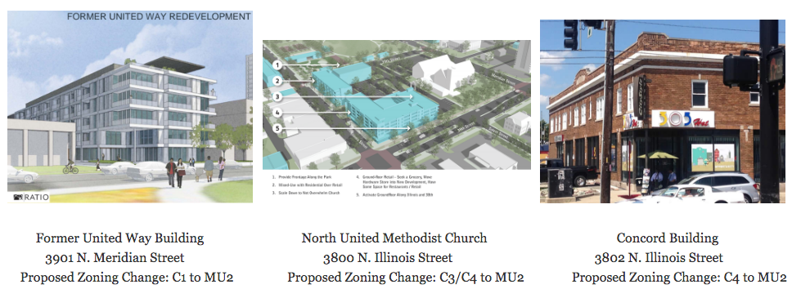

7:20 p.m. - Presentation, Halo Construction & Ivy Hill Ventures, Peter Stewart

Aiming to build high quality, low maintenance and affordable ranch homes in Mapleton-Fall Creek. The current one proposed is at 3265 Ruckle. This is the first of its kind and the first by this company. When the design was shared with the board, there were concerns and they did vote not in favor of the current proposal. The builder has flipped homes and the cost was so extreme that it made more sense for them to develop a plan to build new homes. The designs could be then dressed up as needed. Slab on grade, detached garage. This is all funded by the company and they are aiming to build three this year. They are intending for the homes to be geared toward individuals who would prefer a single-story home.

After a series of concerns, questions, comments voiced by neighbors, community partners and board members, Halo offered to pause their application to Renew Indy and re-work the design and proposal to address the concerns that were voiced as well as to make it more visually blended with the neighborhood. Among those concerns were - committing to energy standards (e.g. energy star), a more laid out example of their financial scope (one concern is around their cost to build and how realistic it is or isn’t) In between this meeting and the next neighborhood association meeting, Halo, representatives from the neighborhood & partners will meet and discuss the designs and potential improvements.

7:56 p.m. - Presentation, Community partners

Brittanie Redd, MFCDC, www.mfcdc.org
- Proposed federal budget cuts are threatening to take away funding from much of what the CDC does in our community. Please contact your elected officials and ask them to give support for this critical funding
- IDA Orientation at the MLK Center, May 4, 6pm-7pm
- Fall Creek Gardens cleanup is from 10-2pm
- Community Initiative, a make-a-thon to brainstorm solutions for food access

Mid-North Food Pantry
- We are offering space for services that benefit our clients.
- Brothers united is doing HIV testing on Wed and Friday mornings from 10-12. No needles, just a mouth swab. At mid north food pantry

Marion County Public Health Department
- IndyGo is hiring full-time positions complete with benefits. It isn’t just a come fill out paperwork, they really want to expand their workforce.
- Project Indy is hiring for a summer youth employment program. Learn more at projectindy.net
- Construction job fair at The Children’s Museum on the 25th from 9-12.
- Celebrate State Champion Basketball on April 15 on the Circle.
- Host a porch party anytime April - May. Spread the word with #PorchParty
- Indy Parks - summer jobs for 18-24

Maple Crossing
- Tarkington Park - Saturday at 9am the restrooms will finally open
- July 29 is the grand celebration opening
- Splash pad testing will be around May 15

8:08 p.m. Meeting is adjourned

